**Competitive Analysis**

Riya Uppal

I’ve been looking for a way to convert audio to sheet music for quite some time, and just until recently, nothing has existed, which is why I wanted to make this program for my term project. However, ScoreCloud has recently been developed, and it does exactly what I want to do with my project. ScoreCloud is described as “Google Translate for music” that instantly turns songs into sheet music and allows for easy composing. Users can record audio from a microphone or a midi keyboard, see the notes appear in real time, and double click to see the notes generated into proper sheet music, which includes the clef and time signature. Then users can manually edit the sheet music and add dynamics and articulation. This program is very easy to use and has a user interface that isn’t too overwhelming even though there are many features included with this program. ScoreCloud will serve as a good model for my term project in terms of user interface and features. There are several features included in this software that I would like to include in my own project, and also some things that I might want to change.

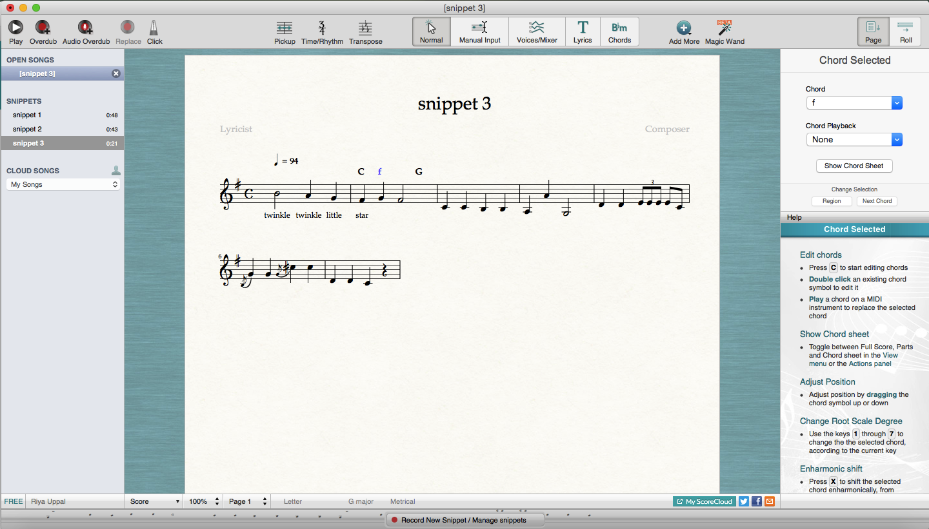 Some things I would like to include in my project are the articulation and dynamics that the user can manually enter. I would even try to have the articulation and dynamics be generated with the sheet music. I also like the feature called audio overdub that lets the user record over the current sheet music. A new staff is generated underneath with the second recording, which gets played back at the same time as the original staff. Lastly, I like that the clef and time signature are automatically generated. This allows users to not have to worry about the technicalities of what they are recording. I was planning on having the users enter in the time signature and the clef, but if I am able to get the time signature and clef to be generated automatically, this feature would add a lot more ease to the process of composition.

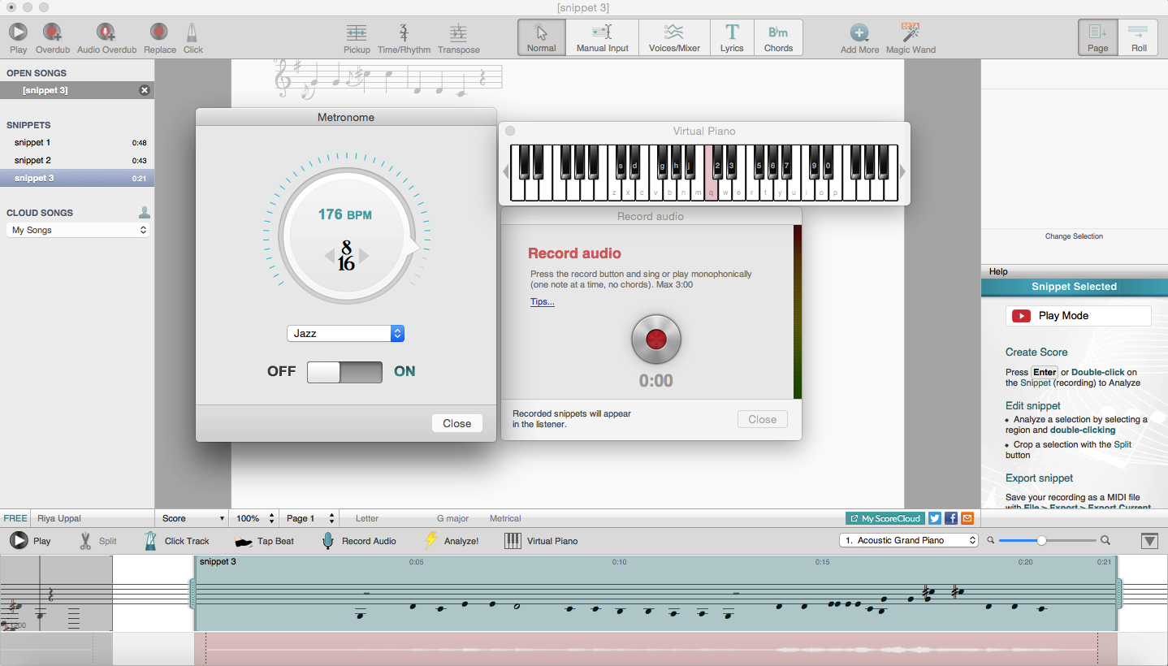

There is something that I would change about ScoreCloud. In the program, it is very easy to edit music, but sometimes this can cause issues. By accidentally clicking the up and down arrow keys, a note can be changed without the user intending it to. Therefore, I would either add an undo button or create an edit mode so that accidental editing doesn’t occur. This is the main issue I discovered while using the program, and to me it seemed like it could be a problem for users.

Other programs that exist do not have a user interface that is as nice as ScoreCloud. AnthemScore is a program that does the same thing as ScoreCloud but uses a convolutional neural network to analyze the music. However, it can take up to minutes to process a single song, whereas in ScoreCloud, the sheet music is generated in just a few seconds. Furthermore, the sheet music needs to be transferred over into a different program if the user wants to edit it. In ScoreCloud, the user can edit the sheet music in the program. Overall, it seems as if AnthemScore is still in its first phases of development. Another software that exists is Sibelius, which again doesn’t have a user friendly interface. It is similar to AnthemScore because the sheet music must be sent to other programs for editing. In my opinion, this is an anti-feature because it makes the user go through another step just to edit music. This is why my program will be a platform for creating and editing sheet music generated by the computer.

Other than these three softwares, there is not much else that is similar to what my program will try to accomplish.